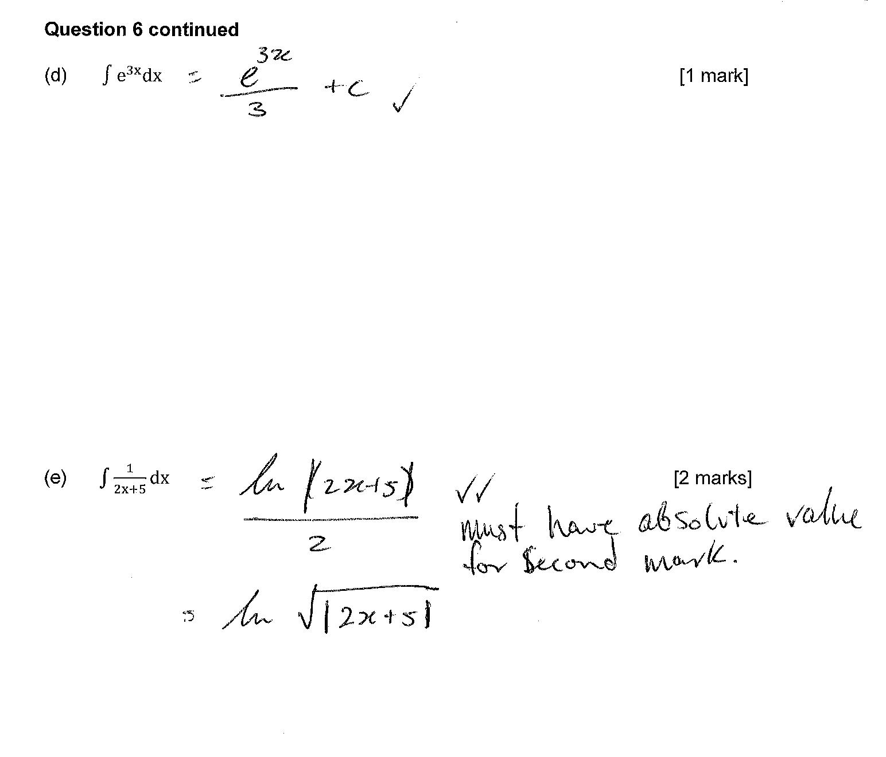

Question 1 (7 marks)
Determine the exact area bounded by the graph of and the -axis for .
Area will be 10 times area for

Question 3 (11 marks)
1 mark | Recognises the need to treat the integral in parts delimited by f(x)=0
1 mark | Determines a first solution for f(x)=0, i.e. x=π/2
1 mark | Recognises the symmetry of the function to obtain $A=10\int_{0}^{π/2}{f\left(x\right)dx}$ or similar
1 mark | Uses an appropriate technique to integrate (i.e. cos³x=cosx(1-sin²x)
1 mark | Determines correct antiderivative
1 mark | Uses correct exact values
1 mark | Gives correct final answer with units.

Determine the following:

(a) (2 marks)

1 mark | Recognises $∫f^{'}\left(x\right).g^{'}\left(f\left(x\right)\right)dx=g\left(f\left(x\right)\right)+c$
1 mark | Correct answer including +c

(b) (5 marks)

1 mark | Chooses appropriate substitution
1 mark | Substitutes correctly
1 mark | Correctly substitutes for bounds (or back-substitutes after antidifferentiating)
1 mark | Integrates correctly
1 mark | Evaluates definite integral correctly

(c) (Hint: Let ) (4 marks)

1 mark | Substitutes correctly
1 mark | Correctly substitutes for bounds
1 mark | Integrates correctly
1 mark | Evaluates definite integral correctly (including understanding that ln 1=0)

(b) The graphs of , and are shown below.
(i) Determine the exact value of , , given that the shaded region has an area of 6 square units. (3 marks)

1 mark | Writes the area correctly as an integral
1 mark | Integrates correctly
1 mark | Solves for a

(ii) Determine the exact area between and the -axis from to .
(1 mark)

1 mark | Evaluates the integral over the specified domain (using technology)

